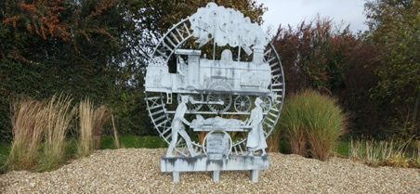
DECHMONT COMMUNITY COUNCIL-WHAT’S INVOLVED?

Being part of the Community Council may seem like a daunting commitment, however it can be as easy or demanding as you wish. Here is an overview to help you consider becoming part of this valuable asset to your community and help Dechmont to continue to be a wonderful place to live.

The Community Council’s role is to:
- Take actions in the interest of the community
- Be responsive to the community it represents
- Liaise with community groups
- Fairly express the diversity of opinions and outlooks of the people
- Express the views of the community to the local authority and other organisations

Members can be elected and co-opted, they should be objective, selfless, honest and have integrity. Whether elected or co-opted they can vote on matters raised at meetings.

The Roles
Office Bearers have distinct roles however they can be assisted in their roles by others.
The main roles and responsibilities of office bearers are:-
- The Chair-ensure that meetings are conducted correctly and run smoothly. Act on behalf of and represent the community council.
- Vice Chair-no specific duties other than standing in for the Chair
- Treasurer- responsible for managing finances and maintaining the accounts.
- Secretary- administrative work e.g. agendas, minutes, communication, and correspondence
- Planning Secretary- deal with matters associated with planning and development.

Other types of members
- Ordinary members- persons with voting rights who communicate the views and opinions of residents
- Youth member (age 14-18yrs)- ascertain and represent the views of young people
- Associate members- persons with particular skills or knowledge who donate their time, as little or as much as they choose. They have no voting rights.
- Ex-officio members- Councillors, MPs, MSPs, MEPs based within the geographical area.

Please consider offering some of your time to your community, any help is greatly appreciated as ‘many hands make light work’.

If you are interested please contact us:
Website:www.dechmontcommunitycouncil.com
Email:dechmontcommunitycouncil@hotmail.com
Or come to one of the meetings

Dechmont Community Council meetings take place on the last Wednesday of each month at 6.00pm (with the exception of July and December) and are approximately 1 hour duration

